Nepal

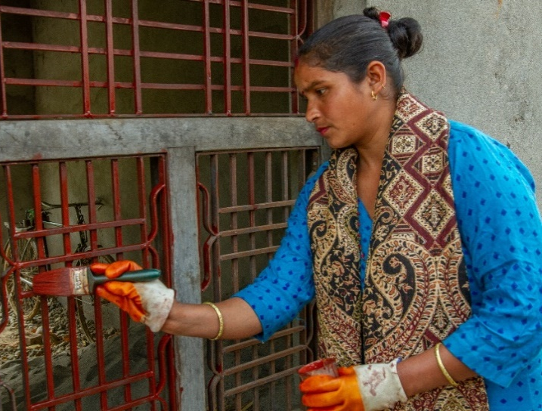
Livelihood benficiary story
Pushpa Lohar, from Kanchanpur, participated in the 52 days house painting training, provided by the Rastriya Haliya Mukthi Samaj and supported by the Bridge Project.
“I never imagined that I would one day become a house painter,” she said. Before the training, she was working as a daily wage laborer, like many women in her community, working hard to break stones into fine pebbles. They were forced to do whatever they were told to, without complaining and for little pay.
She enrolled in the training with other women from her village. During the training, they learnt how to paint houses. All of the participants that completed the training are currently employed.
Pushpa decided to recruit some of the other female participants from the training and created a house painting business. She committed to treat her employees with respect and to pay them decently. And she already received positive feedback from her clients.
“Today my life is amazing, I am the contractor, hiring others to work for me! This training turned out to be the gateway to live a dignified life”. Her living conditions have improved. She was able to repay the loan of $838 she took before the training to buy a piece of land, thanks to the income from her house painting business. She can now send her daughter to a private school and still manages to save up to $14 every month. She also has bigger plans for the future, like opening a paint shop with her husband to increase their income.
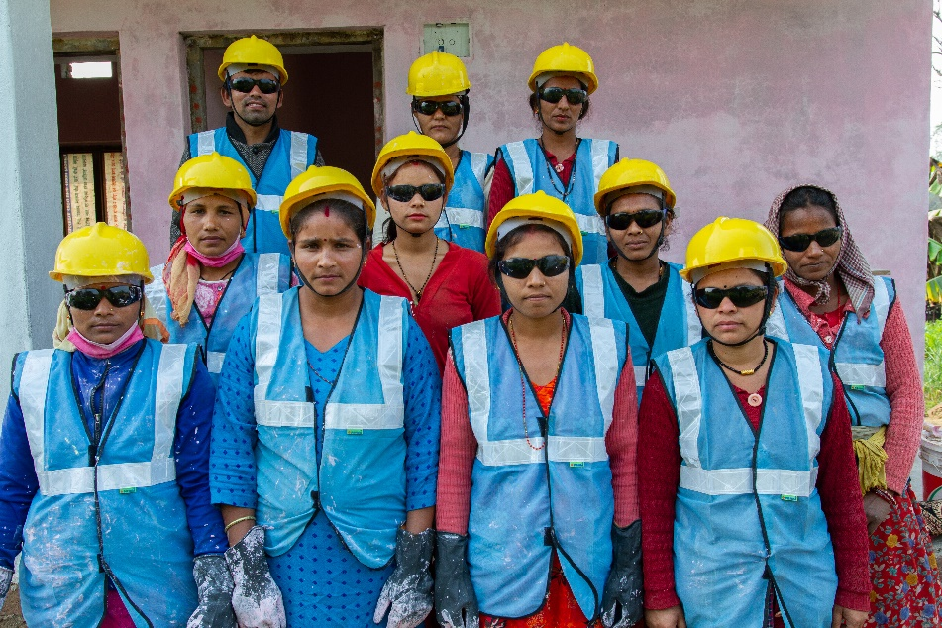
Despite working in a sector that was traditionally reserved to men, her family supports her. “My husband supports my decision, encourages my work and also helps with the household chores while I am at work”. With the other women beneficiaries, they started to overcome gender stereotypes. After seeing their working style and dedication, the villagers believed in their ability as women to paint houses. They also became a source of encouragement for other women in the village. “Seeing myself as a role model to other women makes me proud and happy”.
Niger

Stories through Photos: Support for descents of slaves in Niger.

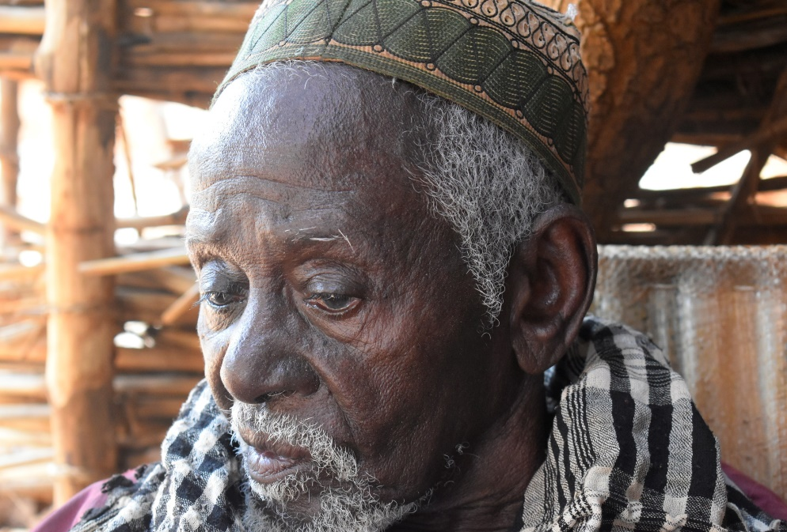 |  | Mr. Harouna, 80 years old, descendant of slaves from Zango Aroki, remembers:  "My fellow men and I were sold or bought as slaves. And even today, our families are still considered slaves. Because of this, we are not given the same rights as others."
Without cultivable land or livestock of their own, the descendants of slaves are often employed as farm workers. | 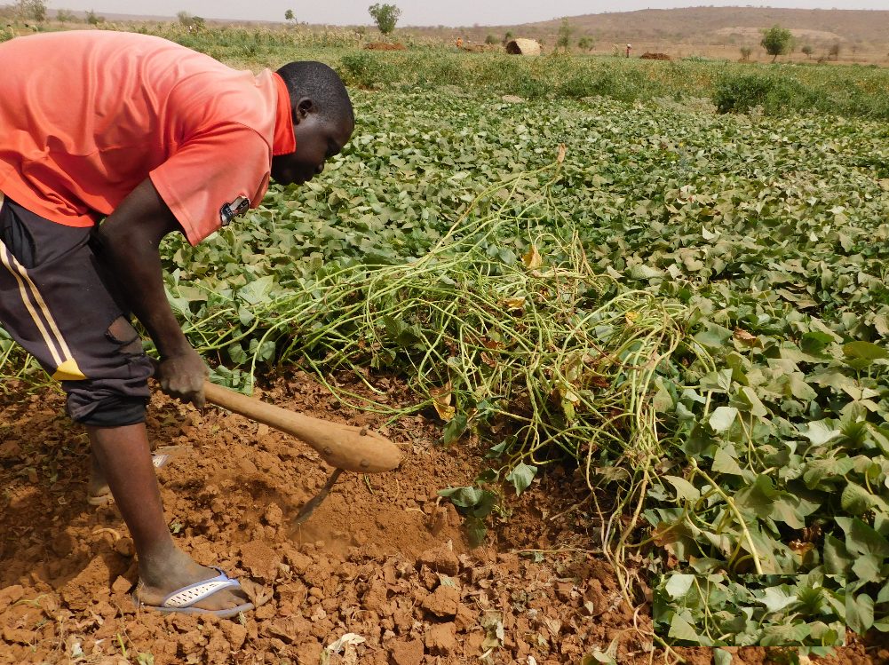

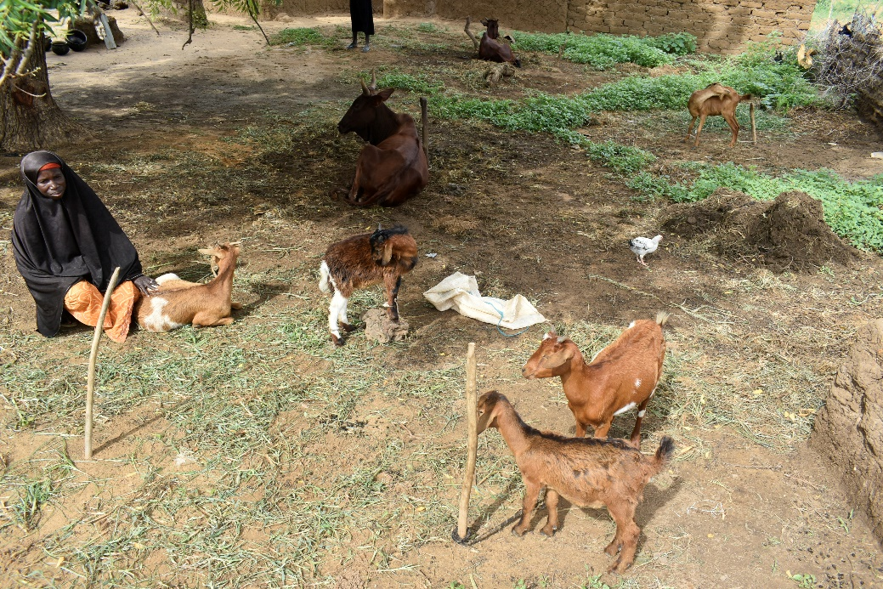 | Or as shepherds.

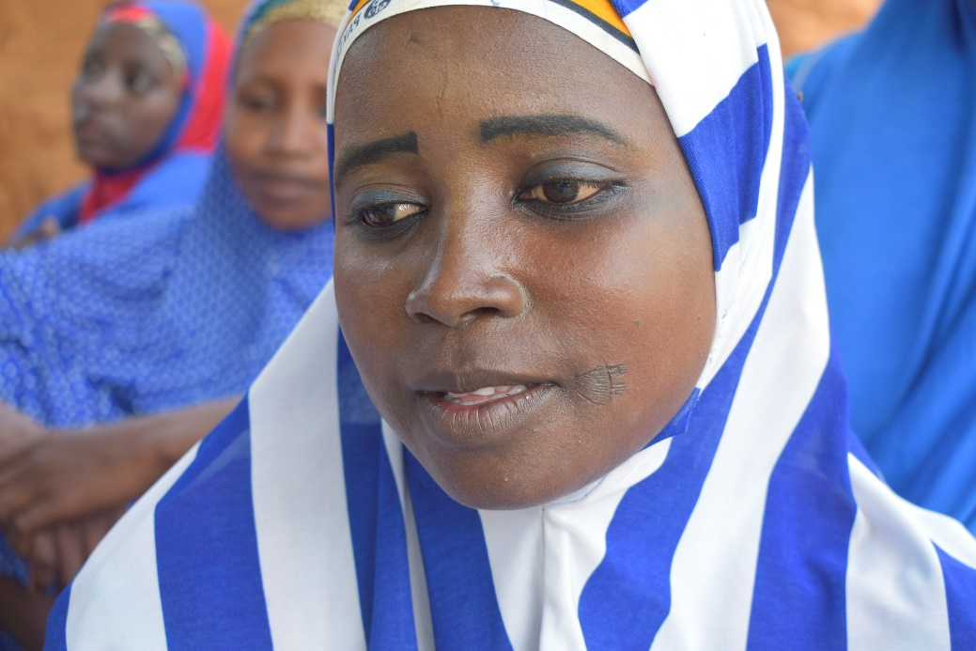 | "I was in first grade when I was forced by my master to drop out of school and marry a man from North Nigeria, as a Wahaya. I was only able to return to my village when my husband died nine years later,” recalls this young woman from Tajaé.

The USDOL-funded ILO Bridge Project, is supporting descendants of slaves to access their basic rights, including through the empowerment of 400 women of slave descent as a result of the livelihood and literacy trainings. The project is being implemented in 22 villages in the Agadez and Tahoua regions. | 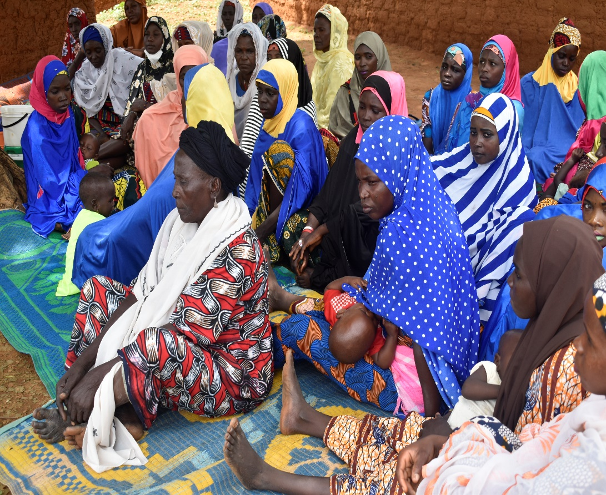

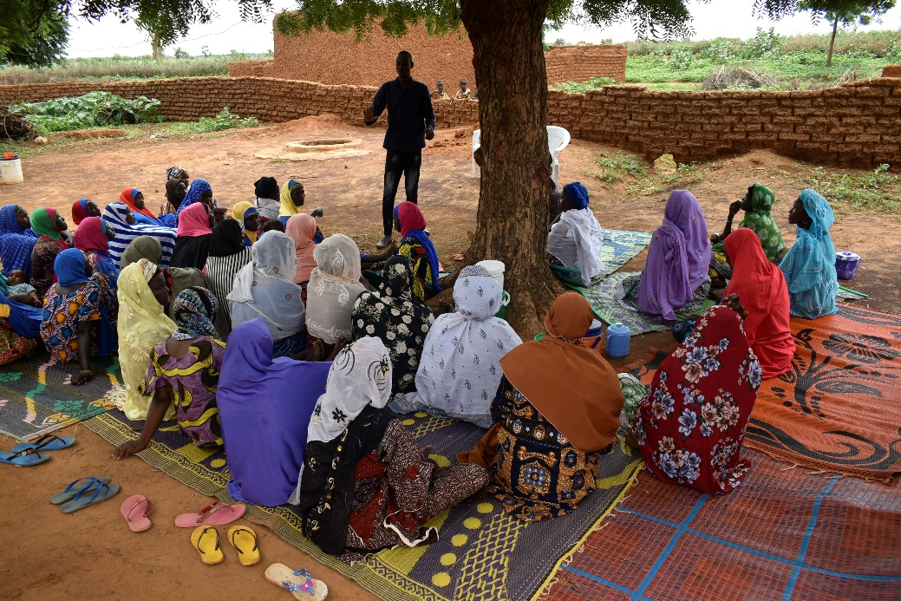 | In each village, women beneficiaries were organized into groups. Paralegals were recruited and trained to support them by conducting awareness-raising sessions about their rights and available remedies and means of asserting them.

Women without birth certificates were offered the opportunity to obtain their documents thanks to a public registration campaign supported by the Bridge Project. | 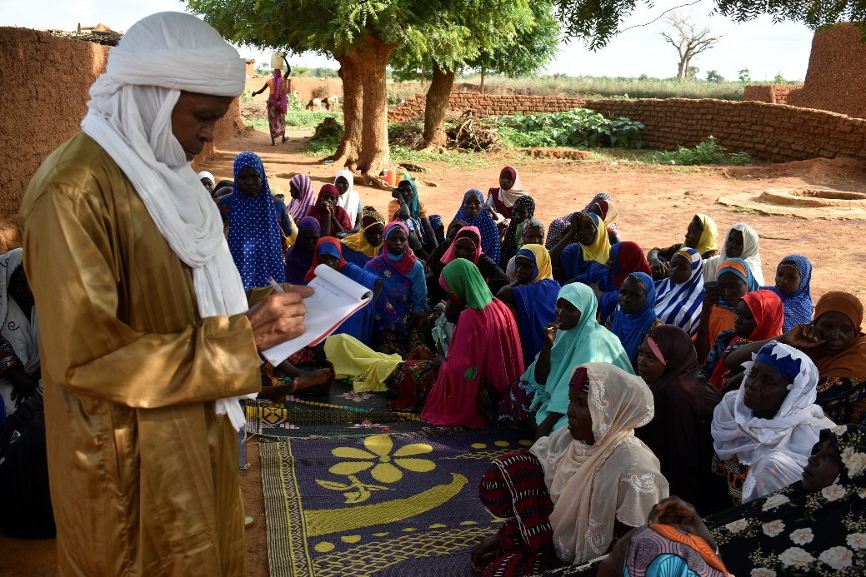

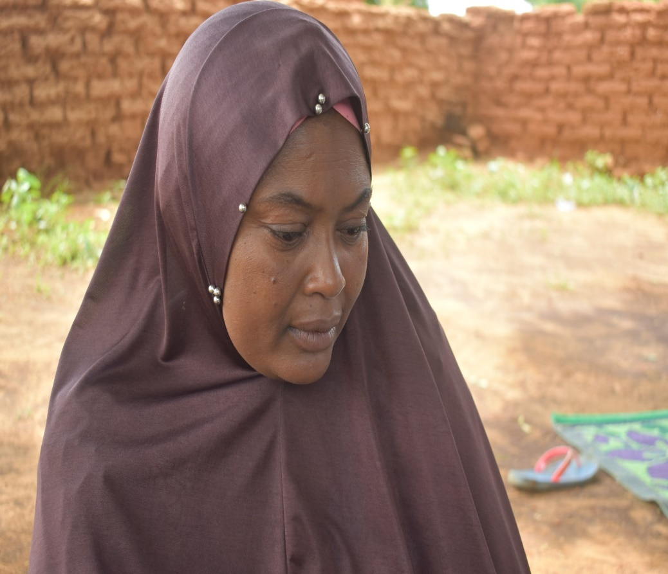 | Hannatou Alkassoum was also forced to drop out of school to be married off by her master. She is now one of the 16 literacy trainers that was trained thanks to the project and has provided functional literacy training to 20 women of the women's group of Tajaé.  "I would never accept that my children suffer the same fate as I did" she says bitterly.

Project beneficiaires, now better informed of their rights, are confident and convinced that things will change... | 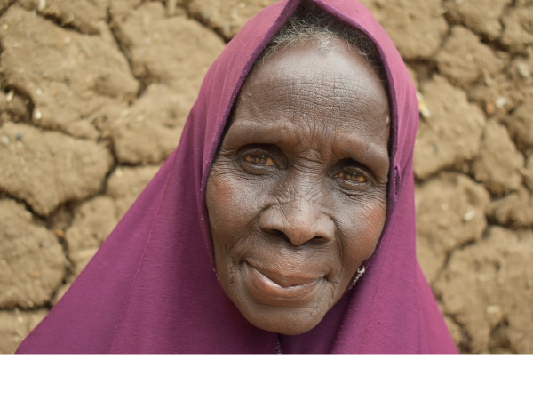

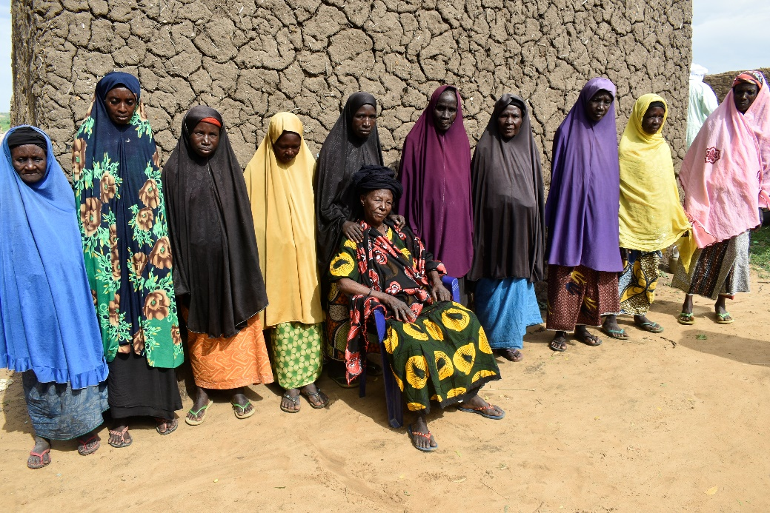 | …and they have started to change. Mrs. Alkousna, a lady of slave descent from Zongon Aboulo, became the Chief of her village (a position hitherto reserved only to men) and an elected official of the rural commune of Malbaza.

