U.S. DEPARTMENT OF LABOR
OFFICE OF WORKERS' COMPENSATION PROGRAMS
DIVISION OF ADMINISTRATIVE OPERATIONS
BRANCH OF ADMINISTRATIVE SERVICES



GOVERNMENT PURCHASE CARD ORDERS
STANDARD OPERATING PROCEDURES

April 4, 2025

Document History
REVISION HISTORY/CHANGE LOG
Date | Version | Author | Revision Description

1. Purpose
This Standard Operating Procedure (SOP) outlines the process and procedures for requesting the Office of Workers’ Compensation Programs (OWCP) government purchase card to purchase services or supplies.
2. Scope
This SOP applies to OWCP Program Offices and covers all government credit card purchase requests.
3. About Government Purchase Card Orders
a. Card assignments:
OWCP is issued two purchase cards (P-Card), which are assigned to DAO cardholders.

b. Process for making purchase requests:

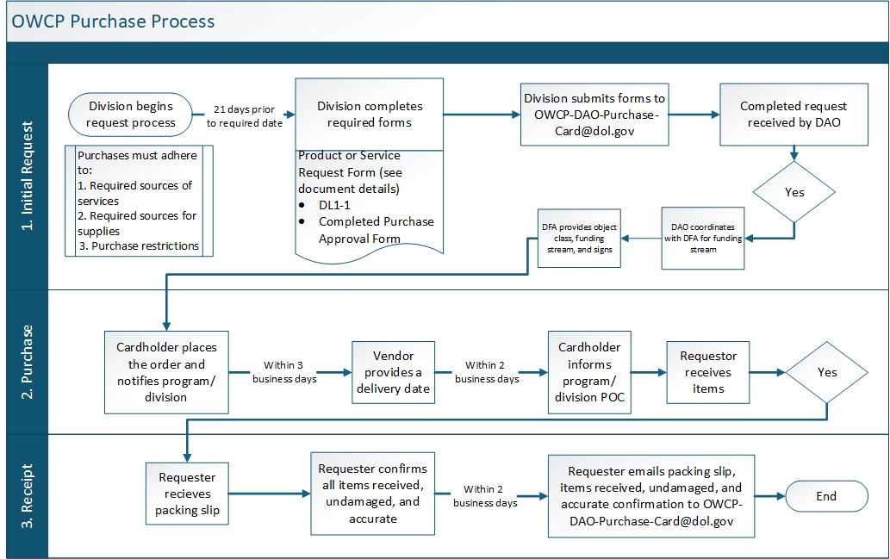
Chart 1: OWCP Government Purchase Card Process Flow Chart

Cardholders are responsible for processing OWCP purchases in accordance with the standard operating procedures outlined in the steps below:
- The requesting Division completes product or service request form, completed DL1-1, and completed Purchase Approval form and submits to OWCP-DAO-Purchase-Card@dol.gov.
- Once the completed request is received by DAO, the cardholder will place the order within 3 business days and notify the program/division. When the vendor provides a delivery date the cardholder will inform the program/division POC within 2 business days.
- Within 2 business days of receipt, the requestor will e-mail the packing slip and confirmation all items have been received, undamaged, and are accurate to OWCP-DAO-Purchase-Card@dol.gov.
c. Complete request consists of:
- GPC Product or Service Request Form which includes:
- Detailed description of the item or service including but not limited to stock number, color, shape, size, quantity etc.
- Office Delivery address, POC for receipt, and back up POC
  - Including email and phone number to ensure proper delivery
- Provide at least 21 days prior to the required date for product. If the delivery date cannot be met, then GPC cardholder will advise.
- Requested Vendor.
- Justification provides an affirmative statement that the required sources (GSA or AbilityOne) did not have the goods or services needed.
2. The DL 1-1 signed by requesting program SES or designee.
- Leave Number 5 Allotment and Appropriation sections blank.
- DAO will coordinate with DFA to provide the funding stream.
3. Purchase Approval Form prepared by DAO. DFA will provide the object class and funding stream and sign.
- GPC- Product or Service Request Form.pdf
GPC Request Form-Example.pdf
DL1-1.pdf
Purchase Approval template_2025.pdf

c. Source requirements
Table1. List of Required Sources
Required Sources for Services | - AbilityOne: Review available services and supplies.  - UNICOR: Explore available services and supplies. (This is only needed for furniture)  - GSA Advantage: Search for GSA Schedule contract vehicles, vendors, available services, goods, and market pricing.
Required Sources for Supplies | - Agency Inventory  - Excess from other Agencies  - UNICOR: Explore available services and supplies (only needed for furniture).  - AbilityOne: Review available services and supplies.  - GSA Advantage: Search for GSA Schedule contract vehicles, vendors, available services, goods, and market pricing.

d. Purchase restrictions
1. Specific transactions are not to be made with the purchase card. These include the following:
- Micro-purchase single transaction threshold of $10,000.
- Monthly threshold of $100,000.
- Services associated with Service Contract Labor Standards FAR 52.222-41 over $2,500 are acquired through another procurement mechanism.
- Advisory and assistance services.
- Construction under Construction Wage Rate Requirements FAR 52.222-6 over $2,000 are made through another procurement mechanism.
- Professional Services over $10,000 are made through another procurement mechanism.
- Copying, printing, duplicating, and reproduction services. Proper advance approval from OASAM's Branch of Printing Services (BPS) is required for all printing, copying, duplicating, and reproduction services. The use of the Government Printing Office (GPO) Express Card and alternative vendor sources for these services is coordinated with BPS in the National Office and OASAM's Regional Administrative Service Officer (RASO) for regional requirements. Additional information and guidelines regarding these services is available by contacting BPS at 202-693-7172 or the OASAM RASO in the region. In these instances, work with DFA.
- Any other means of micro-purchases are discouraged. Exceptions are requested on a case-by-case basis if unavoidable (e.g., MOR, SF182, and/or convenience checks). Please work with DFA when exceptions are needed.
- Products or services from Amazon, eBay or 3rd party payment sources (e.g., cash apps such as PayPal, Venmo, Zelle) are prohibited.

