
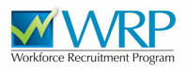
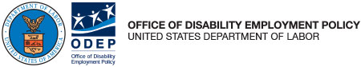

Outreach Toolkit for School Coordinators
Encouraging Students to Explore and Apply for the Workforce Recruitment Program (WRP):

About this Toolkit
Welcome to the WRP Outreach Toolkit for School Coordinators.
The Workforce Recruitment Program (WRP) connects federal employers nationwide with college students and recent graduates with disabilities who are eager to demonstrate their skills in the workplace through internships or permanent jobs. We appreciate you supporting the WRP by serving as a School Coordinator this year.
School Coordinators play a critical role in the WRP in part by helping students and recent graduates navigate the application process. School Coordinators also do the meaningful work of promoting the program and spreading the word about the WRP’s services. Students can’t get to the application stage if they don’t know about the program in the first place!
The WRP Outreach Toolkit for School Coordinators provides tips and tools to help you introduce students and recent graduates with disabilities at your institution to the benefits of WRP as they seek to gain real-world work experience and explore their career options.
Table of Contents
Outreach Toolkit for School Coordinators 1
Outreach and Promotional Strategies 3
Timeline for Promotion and Outreach 5
Promotional Materials 6
Email to Students and Recent Graduates 6
Pitch Letter for Student Newspaper 8
Pitch Letter for School Alumni Magazine 9
Key Messaging 10
WRP Logo 10
Posters/Flyers 11

Outreach and Promotional Strategies
The strategies below can help you promote the WRP. Please note that this list is a starting point. Every school can and should augment these approaches through other outreach channels available to them. Given the WRP application period, promotional activities taking place early in the fall term will have the greatest impact.
- Get social
  - If you have access to social media accounts, managed by your office or others, use them to spread the word about the WRP. Consider also encouraging previous WRP participants to post through their own social media accounts about their experiences. (See our Key Messaging section below for ready-made social content.)
- Email students registered with the disability services office
  - At the start of the fall term, send an introductory eblast to all students registered with the disability services office to inform them about the WRP and how to apply or get more information.
- Coordinate with other student services staff to spread the word
  - Educate your colleagues in career, disability, veterans, and alumni offices about the WRP, and ask them to promote the program among their networks, whether through emails, newsletters, or other channels.
- Contact your student newspaper
  - The WRP can provide fresh content for the school newspaper (or TV or radio station), so try pitching a story to its editor. If available, ask a student(s) who previously participated in the WRP if you can interview them about their experiences. In a similar vein, consider pitching ideas to your school’s alumni magazine or newsletter.
- Display posters/flyers
  - Displaying posters or flyers in your office and around campus is a simple and effective way to garner interest; many WRP alumni say they first learned about the program through a poster on campus!

- Hold an information session
  - Host an information session about the WRP to answer potential participants’ questions at once (you can email wrp@dol.gov for a sample presentation). Be sure to promote the session in advance using some of the same tactics above. If budget allows, consider serving pizza or other refreshments to help entice students to attend.
- Engage your Disabled Student Union
  - If your school has a Disabled Student Union or other affinity group for students with disabilities, ask its leadership to help spread the word about the WRP. (These groups could also be natural co-sponsors for information sessions.) You can reach out to other affinity groups as well—a veterans group, for example—since students with disabilities are represented across all campus communities.
- Link to the WRP from the disability services office and career services office webpages
  - Include a link to the WRP on your office’s website and those of other relevant offices where students might seek information about internship opportunities. You may also include the WRP logo.
- Attend campus career fairs
  - If your school organizes career fairs, ask to participate to share information about the WRP. If possible, recruit previous participants to help staff the booth.
- Share success stories
  - Through the above activities, you may also want to share some WRP “success stories” (i.e., profiles of recent WRP participants), which can help illustrate the range of experiences the WRP offers.
Again, these are just a few ideas for promoting the WRP. We encourage you to get creative based on the outlets available to you. If you discover that a promotional activity proves particularly effective, please share it with the WRP program managers at wrp@dol.gov.

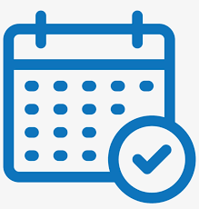
Timeline for Promotion and Outreach
Below is a suggested timeline for WRP promotion and outreach.
August
- Email students registered with the disability services office or on any other relevant email lists.
- Engage with other student services offices (career, disability, veterans, and alumni) to spread the word.
- Include information about the WRP in the career services or other school/office newsletters.
- Display posters/flyers.
September
- Send two reminder emails to students registered with the disability services office.
- Plan and host one or more information sessions.
- Engage your Disabled Student Union, student government, and other affinity groups.
Early October
- Send a final reminder email to students about registering for the WRP.
Ongoing
- Post a link to the WRP on Disability Student Services and Career Services webpages.
- Post on social media platforms.
- Attend campus career fairs.
- Share WRP success stories.
Please note that this schedule is just a guideline. We encourage you to do as many of these activities as often as you can. As long as it’s before the October registration deadline, there’s always an opportunity to do more outreach!

Promotional Materials
Please find below a variety of materials to help you implement the strategies in this toolkit.

Email to Students and Recent Graduates
The sample email below announces the opportunity to apply for the WRP. You can send it specifically to a disability services email list, or to a broader student and recent alumni audience as long as you make clear in the subject line that the program is only for students/recent graduates with disabilities.
Subject Line: Interested in a Federal Career? Apply to the WRP!
Dear [STUDENT OR RECENT GRADUATE NAME]:
Are you interested in a government internship or a long-term job after you graduate? If so, [OFFICE NAME] would like to tell you about a great opportunity for [SCHOOL NAME] students and recent graduates with disabilities.
About the Workforce Recruitment Program
The Workforce Recruitment Program (WRP), coordinated by the U.S. Department of Labor, is a recruitment program that connects federal employers with college students, graduate students, and recent graduates with disabilities who are eager to demonstrate their abilities in the workplace through internships or permanent jobs.
To apply, visit WRP.gov and select “Students Register Now!” to get started.
Who can apply?
Students and recent graduates can apply to the WRP if they:
- have a disability and are eligible under the Schedule A hiring authority;
- are a U.S. citizen or national (including residents of American Samoa and Swains Island); and
- are enrolled in an undergraduate or graduate degree program or have graduated with a degree on or after April 1, 2024.
Applicants will need to upload a current resume, transcript, and Schedule A letter at the time they apply.

New and returning WRP applicants must register and complete an application each year to continue participation.
Registration and application deadline
Registration closes on Sunday, October 4. You will need time to gather your resume, transcript, and Schedule A letter to complete your application, so please don’t delay!
If you need information or have questions about the WRP, please contact [SCHOOL COORDINATOR CONTACT(S)].
We hope your fall term is going well!
Sincerely,
[COORDINATOR OR OFFICE SIGNATURE]

Pitch Letter for Student Newspaper
Dear [NAME OF EDITOR]:
As an avid reader of [NAME OF PUBLICATION], I wanted to offer for publication a brief notice or article about the Workforce Recruitment Program (WRP), an important initiative that offers [SCHOOL NAME] students and recent graduates with disabilities an opportunity to gain valuable work experience.
The WRP connects federal employers with disabled college students and recent graduates seeking internships or long-term jobs.
Please find below a brief notice you may run about the program, or if you’d like to do a more in-depth piece, I’d be happy to talk at your convenience.
Thank you for your consideration.
Sincerely,
[COORDINATOR OR OFFICE SIGNATURE]
**
[SCHOOL NAME] Students and Grads with Disabilities Can Gain Work Experience through Innovative Program
This summer, [SCHOOL NAME] students and recent graduates with disabilities will have the opportunity to seek federal government internships or permanent jobs through the Workforce Recruitment Program (WRP).
The WRP connects federal employers with college students and recent graduates with disabilities who wish to demonstrate their skills in the workplace through internships or long-term positions. Over the years, thousands of college students, graduate students, and alumni have used the WRP to get hired in a variety of roles across the nation for federal agencies.
Applications for the WRP are due in October. Students can learn more by visiting WRP.gov or contacting [NAME OF OFFICE AND/OR SCHOOL COORDINATOR].

Pitch Letter for School Alumni Magazine
Dear [NAME OF EDITOR]:
As an avid reader of [NAME OF PUBLICATION], I would love to see a feature story in your pages about the Workforce Recruitment Program (WRP), an important initiative that can help [SCHOOL NAME] alumni with disabilities gain valuable work experience.
The WRP connects federal employers with disabled college students and recent graduates seeking to demonstrate their skills in the workplace through internships or permanent jobs. For many [SCHOOL NAME] alumni, the WRP has already served as the first step to a successful, long-term federal career.
If you’re interested in learning more, I’d be happy to talk at your convenience.
Thank you for your consideration.
Sincerely,
[COORDINATOR OR OFFICE SIGNATURE]

Key Messaging
Below are key messages about the WRP that are ready for sharing on social media.
Are you a college student, graduate student or recent graduate with a disability who’s interested in learning more about federal employment? Not sure where to start? Check out the #WorkforceRecruitmentProgram at WRP.gov.
Are you a college student, graduate student, or recent graduate with a disability seeking an internship or job? Check out the #WorkforceRecruitmentProgram to get connected to career development opportunities! WRP.gov
The #WorkforceRecruitmentProgram is seeking college students, graduate students and recent graduates with disabilities for the #Fall2026 recruitment season. Apply at WRP.gov
Students and recent grads with disabilities: Apply TODAY for the #WorkforceRecruitmentProgram at WRP.gov to be part of a talent database for job and internship opportunities! Deadline to register is October 4.
Don’t forget to apply for the #WorkforceRecruitmentProgram for college students and recent graduates with disabilities! Registration closes October 4, 2026! Apply at WRP.gov.
If you’re a college student, graduate student, or recent graduate with a disability and are interested in federal employment, please visit WRP.gov to learn more and apply to the #WorkforceRecruitmentProgram.

WRP Logo
If you haven’t done so already, consider linking to the WRP from your webpage or those of other relevant offices. You can use our WRP logo below to embed the link. If you need the logo in alternative file formats, please email wrp@dol.gov.
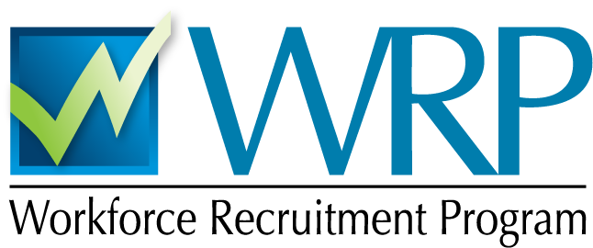

Posters/Flyers

School Coordinators are welcome to display our customizable posters/flyers or create their own with branding for their school and/or office. To download any of our posters, ctrl+click on a thumbnail image below or the link in the caption under it.

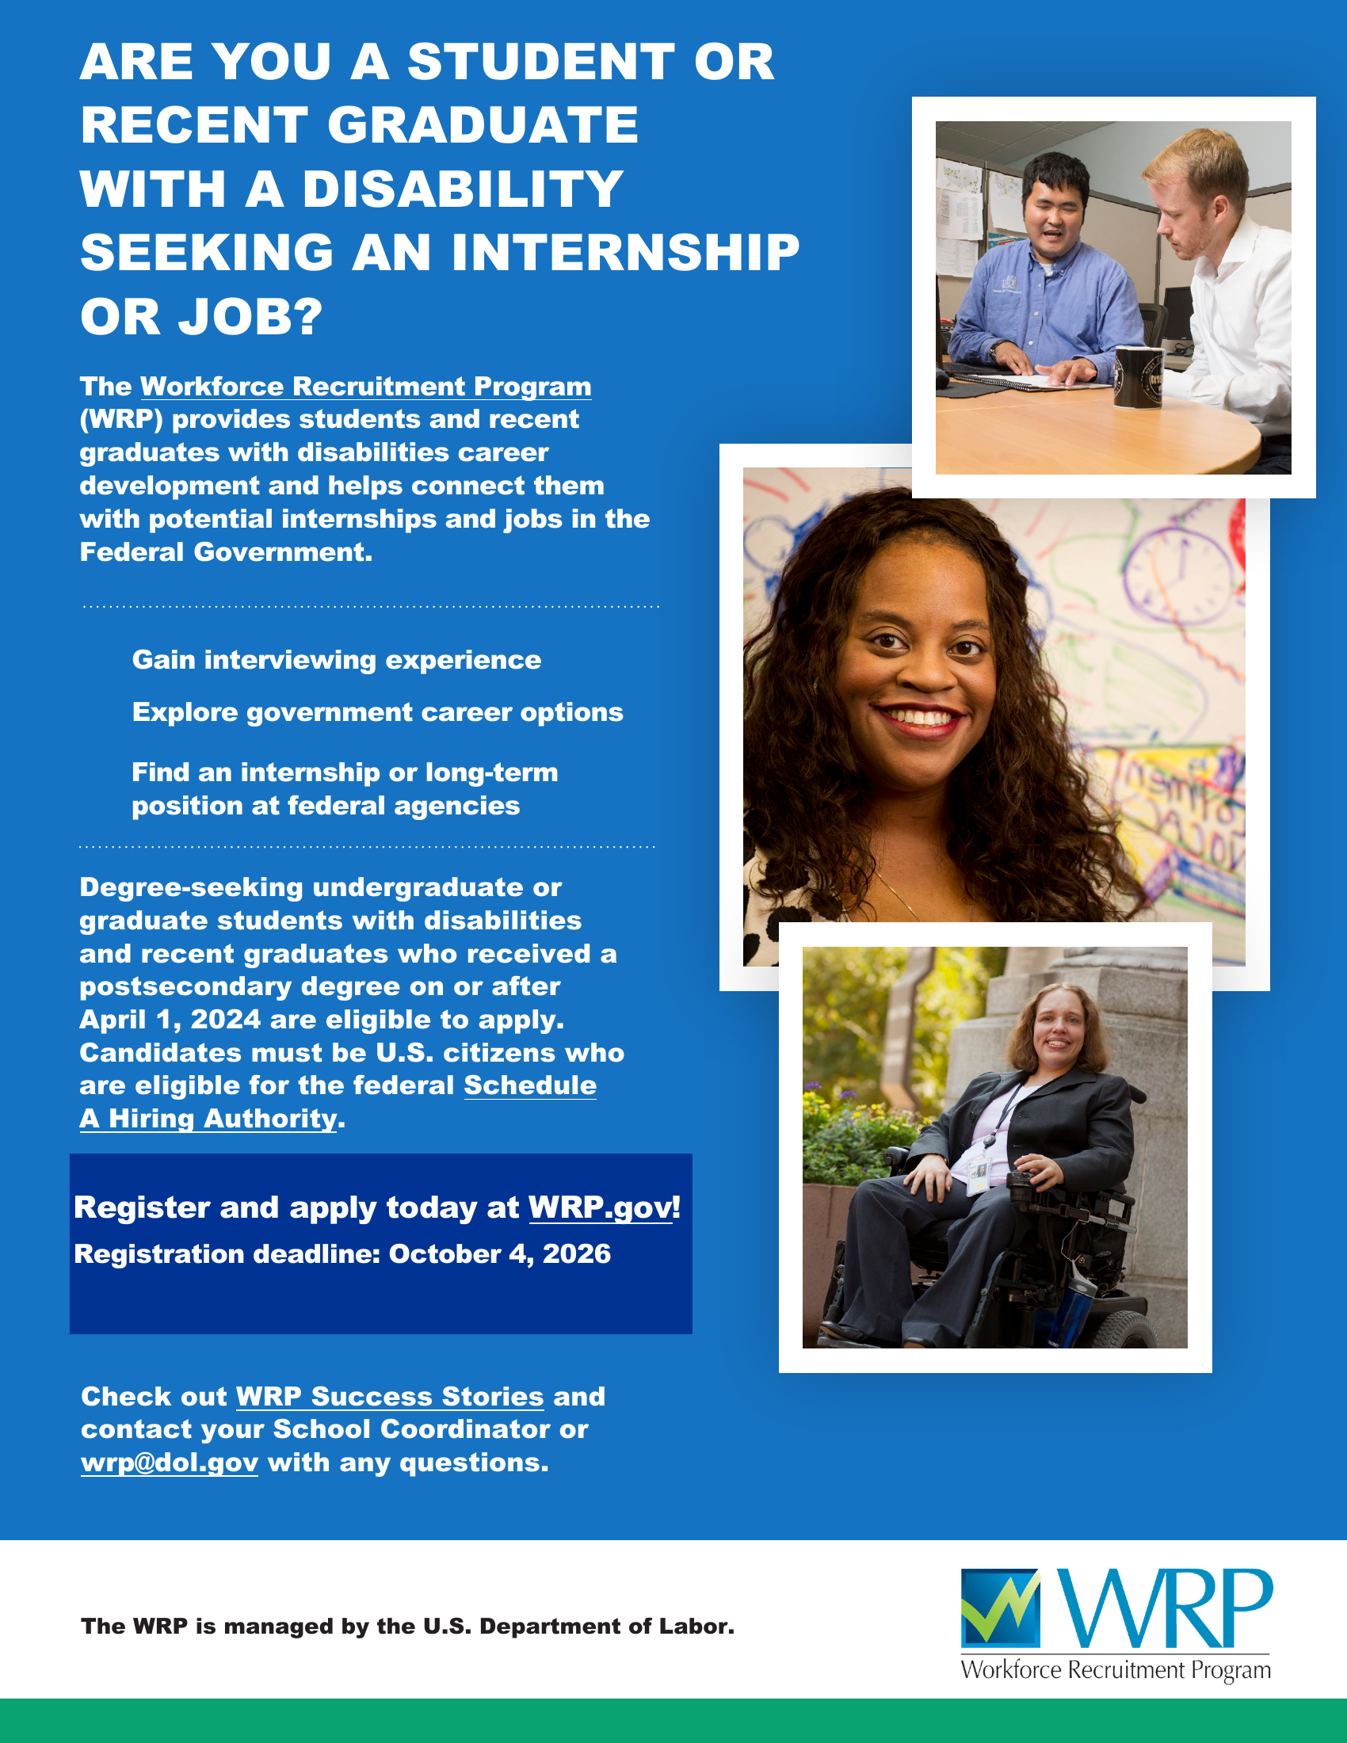
Figure 1: WRP Flyer for 2026
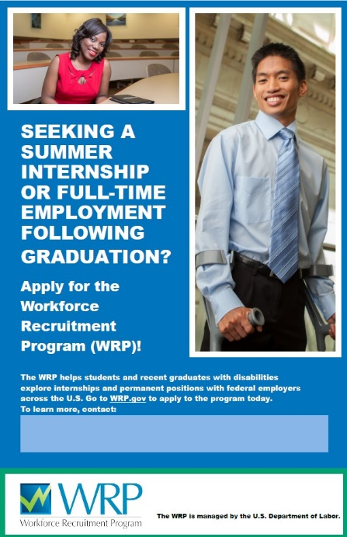
Figure 2: WRP Poster Version A

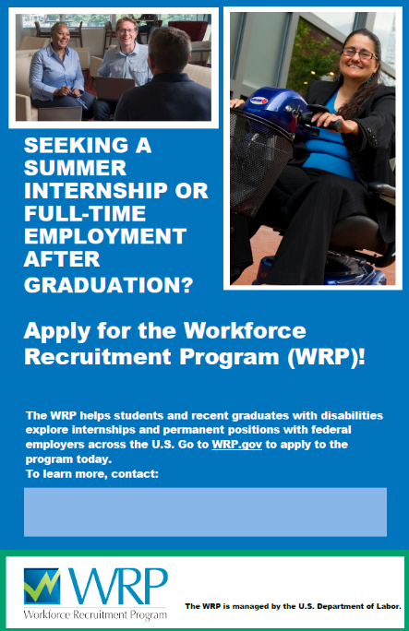
Figure 3: WRP Poster Version B
Figure 4: Schedule A Poster

