Weight of Full Loads of Typical Baskets Used in Cocoa
Basket Sizes:
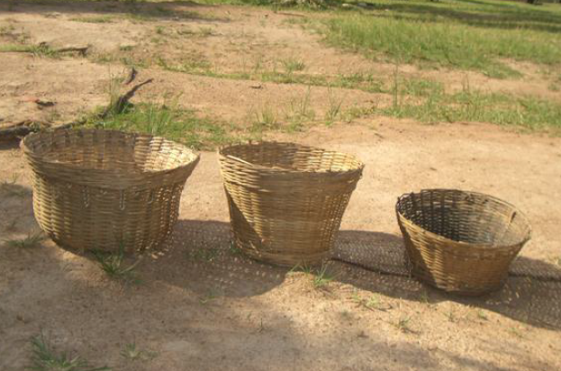
Large
Medium
Small

Full Loads:
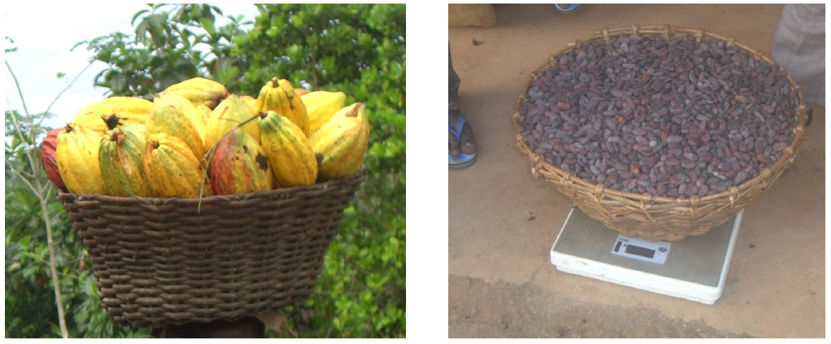
Full Cocoa Bean Load (Dry)
Full Cocoa Pod Load

 | Weight of FULL LOAD
 | Small Basket |  | Medium Basket |  | Large Basket
Load Type | Kgs | Lbs | Kgs | Lbs | Kgs | Lbs
Dry cocoa beans | 8 | 17 | 11 | 24 | 14 | 32
Wet cocoa beans | 25 | 55 | 29 | 65 | 35 | 77
Cocoa pods | 24 | 54 | 28 | 63 | 34 | 74

