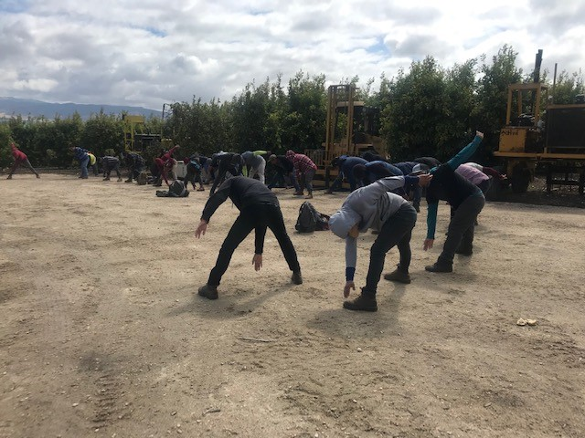
Figure 1: Farmworkers warming up before harvesting lemons. Salinas, California, May, 2019

National Monitor Advocate
Annual Report PY 2018

U.S. Department of Labor Mission: To foster, promote, and develop the welfare of the wage earners, job seekers, and retirees of the United States; improve working conditions; advance opportunities for profitable employment; and assure work-related benefits and rights.

Table of Contents

Executive Summary 3
Annual Report Highlights 4
Background on the Monitor Advocate System 5
Wagner-Peyser Employment Services Provided to MSFWs 7
Outreach 9
Complaint System 12
Conclusion 13

Executive Summary
In this report, pursuant to 20 CFR 658.602 (f), the National Monitor Advocate (NMA) provides an analysis on the services to migrant and seasonal farm workers (MSFW) for the period July 1, 2018 to June 30, 2019, Program Year (PY) 2018. This report is a culmination of the Wagner-Peyser Employment Services provided to MSFWs in PY 2018 through the State Workforce Agencies (SWA). The NMA conducted an analysis of the reports from the RMAs and the SMAs, and selected highlights from the PY 2018 regional annual summaries to develop this annual report.
This report provides an analysis of the PY 2018 data as reported by the SMAs in the Labor Exchange Agricultural Reporting System (LEARS). The report concludes by providing recommendations for technical assistance for SWAs to better serve MSFWs.
The report is divided into the following sections: Annual Report Highlights, focusing on key accomplishments for the program year; background on the Monitor Advocate System; Wagner-Peyser Employment Services (ES) provided to MSFWs; Outreach, comprising a review of the number of MSFWs contacted; the Complaint System, consisting of a review of the total number of complaints filed by MSFWs through the Employment Services and the Employment-Related Law Complaint System (Complaint System), and lastly, a conclusion and the National Monitor Advocate’s recommendations to improve services provided to MSFWs through the Wagner-Peyser program.

Annual Report Highlights
Equity Indicators
SWAs provided the full range of employment and training services to MSFWs on a qualitatively equivalent and quantitatively proportionate basis to the same services provided to non-MSFWs, with the exception of career guidance and the referral to federal training as noted in TABLE 1.

Outreach Contacts
In PY 2018, SWAs and NFJP grantees contacted
416, 977 MSFWs. This is a 9% increase from PY 2017.

New York
New York’s MSFW outreach staff individually develop regional outreach plans, which help the State stay on track to meet overall Agricultural Outreach Plan goals. Each outreach staff is required to write a plan describing the crops grown, peak season for crops, estimated number of employers, and estimated number of MSFWs in their assigned region.

Complaints and Apparent Violations
In PY 2018, MSFWs filed 332 complaints, compared to the 447 filed in PY 2017. However, New York documented 767 Apparent Violations. Of the documented Apparent Violations, 609 were resolved directly with employers and the remaining either were referred to enforcement or are in the process of resolution. Because of New York’s efforts, 117 workers received $97, 317 in unpaid wages or wage supplements in the program year, as reported in New York’s PY 2018 Annual Summary.

Background on the Monitor Advocate System
The Monitor Advocate System was originally established because of the Judge Richey court order (Richey Order). The Monitor Advocate System is responsible for ensuring that the American Job Centers (AJC) are providing equitable services to MSFWs. The Monitor Advocate System is comprised of the NMA team, including the NMA, the State Monitor Advocates (SMA), the Regional Monitor Advocates (RMA), and outreach staff. The Workforce Innovation and Opportunity Act (WIOA) Final Rule pertaining to the Wagner-Peyser Employment Service (ES) can be found at 20 CFR 651, 652, 653, 654, and 658. The Department of Labor issued a Final Rule updating the ES regulations that became effective February 5, 2020, after the end of PY 2018.
In order to monitor the provision of services and ensure that services are provided to MSFWs on a basis that is quantitatively proportionate to all other job seekers, the Monitor Advocate System tracks equity indicators and minimum service level indicators (20 CFR 653.109(g)-(h)).
In 1974, the Judge Richey court order set forth requirements to establish the Monitor Advocate System. Key components of the Monitor Advocate System include outreach, monitoring, advocacy, and the Complaint System. These components combined help MSFWs gain access to resources, ensure their voices are heard, and that they have a safe place to file complaints alleging any violations of the Wagner-Peyser ES regulations and/or other federal, state, or local employment-related laws.

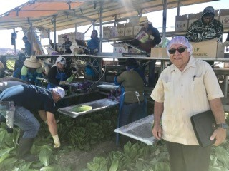
Figure 2 Juan M. Regalado, National Monitor Advocate, visiting Salinas Valley lettuce fields, July, 2018.

Monitor Advocate National Training
A PY 2018 Monitor Advocate National Training took place June 25 to June 28, 2019 at the Denver Federal Center (DFC). The national training brought together over 70 staff that included SMAs, outreach staff, SWA supervisors, Federal Project Officers (FPO) for the National Farmworker Jobs Program (NFJP), and RMAs. The purpose of the national training is 1) To enhance SMAs knowledge, skills, and confidence to fulfill their responsibilities regarding services to MSFWs and to employers who seek workers for agricultural job orders pursuant to 20 CFR 651, 653, 654, and 658; 2) To help SMAs address common challenges; and 3) To help SMAs and SWA supervisors gain a national perspective on the regulations and what ETA expects of them.
Comments obtained from the evaluations from some of the SMAs:
- “As a new outreach member, it has been great being able to network and to listen to others speak about their techniques/styles, their stories.”
- “Excellent historical information and background on regulations and job duties and responsibilities.”
- “It will be extremely helpful because this is my first time attending National Training for the Monitor Advocate System and will be the blueprint for what I need to do at my job.”
- “This is my third SMA training that I have attended and I have been the SMA for two years now, so either I am finally understanding at a higher level or these trainings are improving on how they get the information across, or both.”
The training also provided an opportunity for SMAs to share best practices. The highlight of the best practices, shown in the text box below, was the one from Colorado in the use of the Wager-Peyser 7(b) funds.
ETA also delivered Monitor Advocate training in 2020.
A best practice shared by the SMA in Colorado
States can reserve 10% of their ES appropriation for more flexible uses, under Section 7(b) of the Wagner-Peyser Act. Colorado uses a portion of this “10% money” for Outreach costs to include mileage, travel to training, laptop/cell phone costs, snake boots etc…

Wagner-Peyser Employment Services Provided to MSFWs
All states are required to provide services to MSFWs in percentages equal to or greater than the percentage of services provided to non-MSFWs. In PY 2018, states began reporting these Wagner-Peyser Employment Services through the Workforce Integrated Performance System (WIPS). These services are more commonly known in the Monitor Advocate System as equity indicators. These Equity indicators address ES staff-assisted services and include, at minimum, individuals: (i) receiving staff-assisted services; (ii) receiving career guidance; (iii) receiving job search assistance; (iv) receiving referrals to employment; and (v) receiving referrals to supportive services. WIOA Section 134(c)(2) expanded on these services which are now called career services. Training and Employment Guidance Letter (TEGL) 14-18 provides additional information on the equity ratio indicators. Table 1 below provides a summary of the services provided to non-MSFW and to MSFW participants.

TABLE 1: Wagner-Peyser Employment Services Provided to Non-MSFWs and to MSFWs (Cohort Period: 7/1/2018-6/30/2019)
 | Total Non-MSFW  Participants | Percentage Served | Total MSFW Participants (PIRL DE #413) | Percentage Served | Met
 | Total |  | Total
 | 3,807,065 |  | 62,729
1. Received Basic Career Services | 3,782,564 | 99.36% | 62,612 | 99.81% | Yes
1a. Career Guidance | 1,423,956 | 37.40% | 19,934 | 31.78% | No
1b. Job Search Assistance | 2,406,885 | 63.22% | 43,761 | 69.76% | Yes
1c. Referred to Employment | 1,489,404 | 39.12% | 30,730 | 48.99% | Yes
1d. Received UI Claim Assistance | 373,705 | 9.82% | 10,956 | 17.47% | Yes
1e. Referred to Federally-funded Training | 159,040 | 4.18% | 439 | 0.70% | No
1f. Referred to Other Federal or State Assistance | 298,936 | 7.85% | 18,435 | 29.39% | Yes
2. Received Individual Career Services | 2,040,135 | 53.59% | 40,322 | 64.28% | Yes

Because this year is the first year ETA is tracking the career services, ETA will use this year as the base year to compare these same services in future Monitor Advocate reports.
An analysis of the equity numbers reveals that in PY 2018, the nation did not meet the equity ratio indicator in the percentage of MSFWs receiving career guidance and in the percentage of MSFWs referred to Federal training. As shown in Table 1, 4.18% of all individuals, including non-MSFW participants and MSFW participants, were referred to federal training versus only 0.70% of all MSFWs participants.
Career guidance is often provided by AJC staff, and funded by either ES or WIOA title I. Career guidance may include information on available jobs, training to obtain jobs, and different career pathways the MSFWs could take in the labor market. Also during career guidance, AJC or other staff that provide career guidance to MSFWs, can assess an MSFW’s prior knowledge, skills, competencies, and experiences for adaptability, to support efficient placement into employment or career pathways. At the AJCs, the MSFWs can also obtain education or training, employment services, and supportive services to enter or retain employment. The referral to federal training may include information on training programs supported by the Federal Government, such as WIOA-funded projects, Trade Adjustment Assistance (TAA), Adult Education, Vocational Rehabilitation and Job Corps. These services are also provided to MSFWs at the AJCs.
It is worth noting that of all the career services provided, referral to federal training was the service provided to the smallest percentage of all participants, as well as to MSFWs. The NMA attributes this to the way SWAs are now capturing this data. The NMA Team will work with the RMAs to develop a plan of technical assistance to assist the SWAs to improve in this area. The plan will include doing more outreach to significant areas on career services, and ensuring AJCs and SMAs have access to English and Spanish-language career resources which AJC and outreach staff can provide to MSFWs.

In the Job Search Activities category, 69.76% of MSFWs received job search activities, while only 63.22% of the non-MSFW participants received this same service. Likewise in the Received Individual Career Services category: 64.28% of MSFWs received this service, while only 53.59% of the non-MSFW participants received this same service. The NMA attributes this high level of services to MSFWs to the many SMAs that provide peer-to-peer technical assistance to AJC staff on MSFW activities, and the training tools and resources they share with AJC staff, as reported in many of the SMAs’ annual summaries. Other SMAs provide technical assistance to AJC staff on issues related to proper identification of MSFWs, meeting the needs of MSFWs, and reporting services.
Georgia developed standardized outreach materials for agricultural employers with descriptions of available business services and for MSFWs with descriptions of career and supportive services available at career centers and other service providers in the State.
New York also reported several cross-training opportunities for staff, including training to Significant MSFW One-Stop Center staff on MSFW services prior to peak season, bi-monthly training for outreach staff on ES, and trainings to partners on the workforce system.

Based on information from the PY 2018 RMA summaries, states have expressed a concern identifying whether a participant meets the definition of farmworker. The SWAs provide all applicants the option to register for Wagner-Peyser services remotely, using the states’ internet-based, self-service systems. This often presents a problem for some MSFWs since they may not understand the questions on the states’ websites; consequently, they incorrectly identify themselves as MSFWs. The NMA Team will provide technical assistance to RMAs and SMAs so they can train the local Wagner-Peyser staff to properly review and identify MSFW and non-MSFW applications so they are coded properly. The technical assistance will focus on ensuring SWAs are complying with 20 CFR 658.601(a), which requires SWAs to “establish and maintain a self-appraisal system for ES operations to determine success in reaching goals and to correct deficiencies in performance.”

Outreach
In Texas, the Monitor Advocate provided technical assistance to AJCs on, among other things, prompting local workforce development areas to include a MSFW link to their Facebook pages to broaden outreach capabilities in their respective areas.
The SMA in Utah focused on staff efficiency regarding outreach activities, and developed and implemented outreach training.
Florida has established MSFW service policies for outreach worker training, complaint procedures, farm worker supportive services, housing inspections, and field checks.

This section discusses a critical component of the work of the Monitor Advocate System. SWAs are charged with operating an outreach program dedicated to locating and contacting MSFWs who are not being reached by the normal intake activities conducted by the local offices (20 CFR 653.107). The objectives of the outreach program are to 1) provide basic employment and training services where MSFWs work, live, or gather; inform MSFWs of the full range of services available at the AJCs; 2) explain to MSFWs the availability of the Complaint System; and 3) provide needed supportive services and referrals to other service providers on an as-needed basis. To realize these objectives, it is imperative that outreach staff make themselves visible in their communities, and establish and maintain strong working relationships with MSFWs and employers.
TABLE 2: MSFW Outreach Contacts for
PYs 2017 and 2018
SWA  Contacts | NFJP  Contacts | Total
PY 2017
299,031 | 79,284 | 378,315
79% | 21%
PY 2018
339,258 | 77,689 | 416,947
81% | 19%

Table 2 summarizes the total number of outreach contacts made by the SWAs and the NFJP grantees for PY17 and PY18. In PY18, there was a 9% increase in outreach contacts compared to PY17.
As required by the regulations at 20 CFR 653.108(l), all SMAs with the exception of one developed a Memorandum of Understanding (MOU) during PY18. Since the end of PY 2018, that state already has developed MOU with the NFJP grantee. Additionally, due to the guidance provided in TEGL 8-17, collaboration between the SMAs and the NFJP grantees has increased.
In one region, a positive development with MOUs with other partners is that many more States are in the process of developing MOUs with nearby Mexican Consulates, further expanding access to information for MSFWs.
Through the PY 2018 SMA and RMA summaries, the NMA identified the following trends:
Colorado
SMA assisted in planning and presenting for the Mexican Consulate during “Semana Laboral” (Labor Day Week). The presentation identified the services available to the agricultural community, job seekers, basic labor rights and labor law information, and outreach services.
- States shared that they focused on staff efficiency regarding outreach activities;
- States developed and implemented outreach training;
- States indicated that outreach staff hired are frequently not from MSFW backgrounds nor racially or ethnically representative of MSFWs in the service area; and
- States reported a reduction in state outreach activities due to sudden staff turnovers, and did not designate outreach staff to conduct outreach activities. Additionally, in one ETA Region, the RMA is planning onsite reviews for several of these states in the near future. In another region, the RMA will continue to work closely with five SMAs to assist in the resolution of the common finding regarding insufficient outreach to MSFWs.

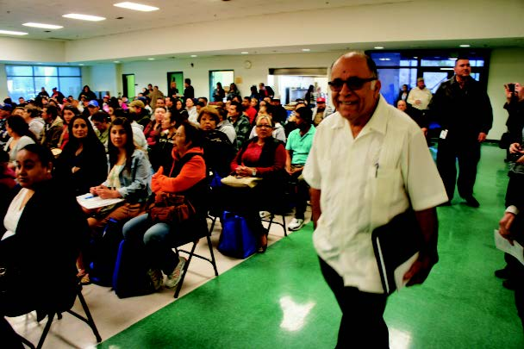
Figure 3 Farmworker Appreciation Day, September 24, 2018. Juan M. Regalado, NMA, getting ready to address farmworkers, Kern County, CA
The Monitor Advocate System team, including the NMA, RMA, SMA, and outreach staff, contribute to the growing trend in outreach contacts to consistent training and technical assistance provided by the NMA team to federal and state staff.
Arkansas
The new SMA in Arkansas continued to learn MSFW system requirements with technical assistance from the Region 4 RMA, and peer-to-peer, on-site technical assistance from Colorado’s SMA. The SMA:
- Initiated the development of MSFW program policies and procedures.
- Provided training in sexual harassment, human trafficking, outreach staff roles and responsibilities, and housing inspections.
- Increased contact and collaboration with the Arkansas Human Development Corporation, sec. 167 NFJP grantee.

The overall trend in outreach contacts continues to rise from 275,891 in PY 2009 to 416,947in PY 2018.

Complaint System
Each state agency must establish and maintain a Complaint System. The Complaint System covers complaints and apparent violations related to the Wagner-Peyser ES regulations and other employment-related laws (20 CFR 658). An apparent violation occurs when a SWA, ES office employee, or outreach worker observes, has reason to believe, or is in receipt of information regarding a suspected violation of employment-related laws or Wagner-Peyser ES regulations by an employer. While the Complaint System is available to all workers (whether they are MSFWs or not), this section focuses on how the Complaint System specifically served MSFWs.
In PY 2018, New York reported 113 complaints, 24 were related to agricultural industry. The State resolved 22 of the agricultural-related complaints and referred the remainder to enforcement agencies.
TABLE 3: Total Complaints Received by Employment Service Offices
for Program Years 2017 and 2018
National Totals
PY | Total | MSFWs | Non-MSFWs
2017 | 3,502 | 447 | 3,055
2018 | 3,053 | 332 | 2,721

Success Story Provided by New Jersey SMA:

“During the height of the growing season and in response to an apparent violation or complaint, State and Federal agencies shut down a farm site due to living conditions and wage issues. Five Puerto Rican farmworkers were out of work and had no place to live. New Jersey Department of Labor and Workforce Development (NJ DOL) staff including the State Monitor Advocate, Wage and Hour, and MSFW Outreach took immediate action to assist the workers. Staff contacted WIOA Section 167 grantee PathStone to see if they could provide emergency housing and MSFW outreach staff contacted area farmers to place the workers in new jobs. Within hours, staff were able to find new jobs and housing for the workers. On the following Monday, the workers started work at the new employer. This success story is not unique and is an example of the value and partnerships New Jersey offers to safeguard the rights of our MSFW community.”

The success story illustrated above is not unique to the State of New Jersey. Throughout the nation, SMAs, outreach staff, and NFJP grantees come together in times of need to assist MSFWs in providing job search assistance and supportive services.

Conclusion
The quantitative and qualitative analyses of the services provided to MSFWs through the AJCs indicate that states continue to provide services to MSFWs that are qualitatively equivalent and quantitatively proportionate to those same services provided to non-MSFWs, with the exception of referral to career guidance and the referral to federal training.
The strong numbers in outreach contacts by the SWAs and the NFJP grantees will continue to ensure that outreach staff are providing MSFWs information about employment and training services, assistance, and follow-up activities. The NMA team will continue to provide technical assistance to the RMAs, SMAs, and outreach staff on the Complaint System to ensure that if MSFWs encounter workplace violations, they know where and how to file complaints.

See the Judge Richey Court Order at: http://www.vec.virginia.gov/vecportal/employer/pdf/richeyorder.pdf.
20 CFR 652.204: Sec. 7(b) of the Wagner-Peyser Act provides that 10 percent of the State's allotment under the Wagner-Peyser Act is reserved for use by the Governor for performance incentives, supporting exemplary models of service delivery, professional development and career advancement of SWA staff, and services for groups with special needs. However, these funds may flow through the one-stop delivery system.
Data obtained from WIPS Wagner-Peyser/Monitor Advocate Roll-Up Report for PY 2018. The data includes career services provided to all participants and to MSFWs in the Wagner-Peyser ES Program.
Source: Labor Exchange Agricultural Reporting System (LEARS) Reports for PY 2017 and PY 2018.

