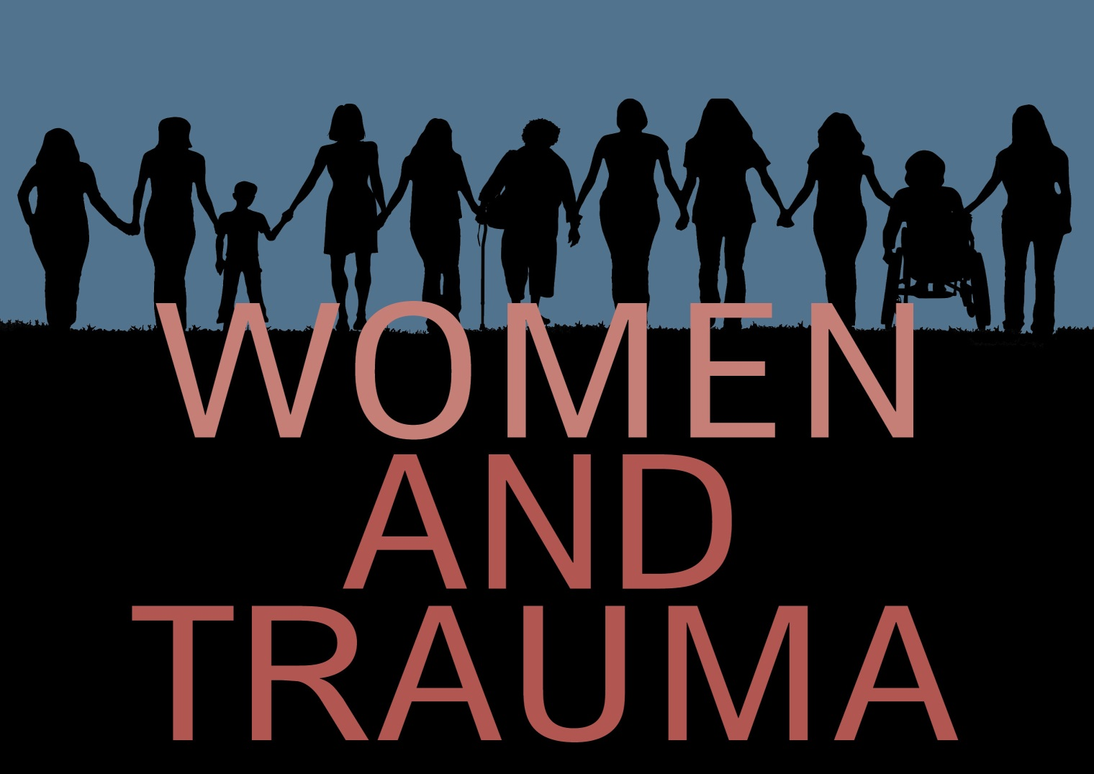

Building a Trauma-Informed Nation:
Moving the Conversation into Action

Report, July 2016

Federal Partners Committee on Women and Trauma

Building a Trauma-Informed Nation: Moving the Conversation into Action
September 29-30, 2015
Hosted by the Federal Partners Committee on Women and Trauma

Goals of the Event
In September 2015, the Federal Partners Committee on Women and Trauma hosted Building a Trauma-Informed Nation: Moving the Conversation into Action (BTIN) to highlight violence and trauma as a public health issue requiring urgent and immediate attention. This two-day event was conceived, developed, and implemented by the Committee to:
- Highlight emerging models and effective practices in the implementation of trauma-informed approaches, with an emphasis on cross-agency, systemic efforts at the federal, state and community levels.
- Demonstrate survivor resilience and encourage the inclusion of women and girls impacted by trauma.
- Facilitate and catalyze planning for the advancement of trauma-informed approaches.
- Begin a conversation about measureable changes resulting from these efforts.
- Create a “community of communities” for sharing information and resources after the event.
BTIN builds upon two previous national events held by the Federal Partners Committee on Women and Trauma that raised awareness about the impact of trauma and mobilized Federal agencies to address its consequences. Federal actions, in turn, had stimulated change across the country. By 2015, a growing number of organizations and communities were adopting trauma-informed approaches, and many were asking for assistance with implementation. The 2015 event provided a forum to share promising practices and innovations, engage in peer-to-peer dialogue, and to help participants plan strategically to move implementation of trauma-informed approaches forward.

Background of the Committee
The Federal Partners Committee on Women and Trauma was initiated in April 2009 by SAMHSA’s Center for Mental Health Services as a workgroup within the Federal Partnership on Mental Health Transformation. The Federal Partnership was established in response to the President’s Executive Order 13263 (2002) and the President’s New Freedom Initiative Commission on Mental Health. The Committee’s work is guided by the recognition that the impact of violence and trauma on women is a public health problem with profound consequences for many different agencies. Initial efforts focused on identifying the impact of trauma on the mission and activities of each agency, raising awareness about trauma across government, and promoting evidence-based public health practices. The workgroup rapidly expanded in membership, coordinated successful national roundtables in 2010 and 2011, and released reports in 2011 and 2013. In 2011, the workgroup became an ongoing committee, and began offering targeted training and a webinar series. By the end of 2015, the Committee included more than 100 members from 40 divisions of 13 Federal agencies.

The Event Framework and Highlights

An innovative format offered three ways to participate: 1) at the “home site” at the U.S. Department of Labor in Washington, DC, where the speakers and panelists gave their talks; 2) via a WebEx platform with individuals at their offices or homes; and 3) via the same web platform at “amplifier sites” set up in communities across the country. Amplifier sites allowed groups of people to participate remotely, to connect with others interested in the same issues, and to engage in local planning and action. All participants were able to submit questions at the “home site” and also via the WebEx Chat box. Most of the questions were answered during an ample question-and-answer period. All unanswered questions during the event were responded to with responses from the appropriate speakers and sent to the questioners following the event.
Four “Catalyst Sessions” focused on (1) trauma-informed communities, (2) health care, (3) education, and (4) justice. These sessions brought together practitioners implementing cross-agency trauma-informed approaches across the country. All four sessions also discussed how employment and workforce issues are affected. Throughout the program, social determinants of health were highlighted, including racism, poverty, discrimination, and historical trauma. Speakers emphasized empirically supported approaches and experience in the field, consistent with this committee’s effort to adhere to empiricism in its work. Successful examples of violence prevention, resilience-building, and trauma-informed interventions were included.

Opening Remarks and Keynotes

Opening remarks from Carrie Bettinger-Lopez, White House Advisor on Violence against Women, made it clear that this effort has strong support at the highest levels of the Federal Government. Building on the groundbreaking work of Senator Biden in the 1990s and the Violence Against Women Act, the White House has made a commitment to ensure that all women and girls can live free from violence and abuse. Bettinger-Lopez also described efforts to integrate violence prevention with trauma-informed approaches.

We are working to address root causes, challenge stereotypes, curb victim blaming, prioritize prevention, and focus on those who have been placed at the margins of society.
Carrie Bettinger-Lopez, White
House Advisor on Violence against
Women

Kana Enomoto, Acting Administrator of SAMHSA, explained how her agency is working to establish a common framework for trauma-informed approaches and to address the consequences of trauma across a wide variety of populations and settings, including mental health and substance abuse, primary health care, juvenile and adult justice settings, HIV/Aids, homeless services, and others.
The SAMHSA concept paper on trauma and trauma-informed approaches is the most frequently downloaded document on the website.
Kana Enomoto, Acting
Administrator, SAMHSA

In the opening keynote, Dr. Gary Slutkin, Founder and Director of Cure Violence, described how violence acts like a communicable disease: it occurs in clusters and epidemic waves, can be transmitted between individuals, and the primary risk factor is previous violence. He noted that violence prevention and related fields have been held back not because people don’t care or lack resources, but because our systems have been constructed on the basis of an incorrect theory. Once we start asking new questions, based on the science of trauma, new solutions emerge–including effective program models, new categories of workers, innovative training approaches and even new language. The closing keynote and call to action was delivered by Dr. Teresa Brockie, Research Nurse Specialist from the National Institutes of Health Clinical Center. Like Dr. Slutkin, Dr. Brockie highlighted the public health impact of trauma, with particular reference to Indian country. She described how historical trauma, operationalized as negative boarding school experiences, leads to increased rates of poly-drug use, suicide, depression, and PTSD. She stressed the importance of a coordinated, interagency response and highlighted the need for national policy leadership in addressing these issues.

Exposure to violence is processed by the brain just like exposure to TB is processed by the lungs.
Gary Slutkin, M.D.
Founder and Director,
Cure Violence

The Catalyst Sessions
Each catalyst session included a plenary speaker who set the stage by describing the impact of trauma on the area of concern—communities, justice systems, health care settings, and schools. Plenary speakers were followed by panelists who shared their experience with implementing a trauma-informed approach and/or participating in trauma-informed services.

In the “Communities” Catalyst Session:
- Father Jeff Putthoff, Founder of Hopeworks ‘N Camden, described how working with youth exposed to high levels of community violence can take a toll on staff, and how adopting a trauma-informed approach can address burnout and increase service effectiveness.
- Nancy Hardt, University of Florida College of Medicine, talked about using geo-mapping to identify community “hotspots” where trauma-related problems clustered, and about using maps as an advocacy tool.
- Brenda Vezina, Director of Central Massachusetts Programs at the Transformation Center, provided a case study of peer-led community healing through a process emphasizing personal connections and shared experiences.

In the “Justice” Catalyst Session:
- Catherine Pierce, Senior Advisor to the Administrator, U.S. Department of Justice, Office of Juvenile Justice and Prevention Programs, provided examples from the Defending Childhood Initiative of local communities and tribes that are working to reduce violence against children, address historical trauma and racial disparities, and ensure that children and families receive needed treatment and supports.
- Rebecca Campbell, Professor, Psychology and Program Evaluation, University of Michigan, described how training on the neurobiological and behavioral impacts of trauma changes the way police relate to rape victims and improves the experience of survivors.
- Taylar Nuevelle, Jail and Prisons Advocacy Project and Writer, related how she was traumatized by people in the justice system who did not understand the impact of trauma, beginning with the courts.
- Beth Medina, CEO/Executive Director, the Innocent Justice Foundation, described the secondary trauma experienced by law enforcement personnel working to apprehend child predators, and how learning about the impact of trauma can help them build resilience and better manage their health.

In the “Health Care” Catalyst Session:
- Naina Khanna, Executive Director, the Positive Women’s Network, talked about the impact of violence and trauma on women (including transgender women) living with HIV, who are disproportionately poor and women of color.
- Karen Frensley, Program Manager, Oklahoma Department of Mental Health and Substance Abuse Services, described how the state of Oklahoma used a SAMHSA-funded mental health transformation grant to implement trauma-informed approaches, using trauma-specific services, peer support, and collaboration with Medicaid, the state Attorney General’s office, and the Coalition Against Sexual Assault and Domestic Violence.
- Kate McGraw, Associate Director, Psychological Health Clinical Care, Defense Centers of Excellence, discussed a toolkit developed by the DOD, VA, and others to help health care providers respond compassionately to patients reporting sexual assault, create a safe environment, assist with systems navigation, and ensure that rights are protected.
- Elizabeth Prewitt, ACES Connection, provided information about how to use the ACEs (Adverse Childhood Experiences) connection social networking site—with more than 5,000 members and numerous topical, state and local discussion groups – to support local change efforts.

In the “Education” Catalyst Session:
- Barb Trader, Executive Director, TASH, presented data and case studies of children with disabilities who have been traumatized in school systems through the use of seclusion and restraint and other disciplinary techniques, as well as examples of schools that have successfully changed their cultures using trauma-informed approaches.
- Leslie Lieberman, Director of Special Initiatives and Organizational Consulting, Health Federation of Philadelphia, highlighted the importance and effectiveness of using trauma-informed approaches as early as possible, including in daycare and preschool settings.
- Suzanne Savall, Principal of the Otis Orchards Elementary School, Spokane, Washington, described how as Principal of an elementary school, she was able to institute changes in teaching routines and administrative practices to address trauma in children and families, and how these changes led to positive educational outcomes.
- Marsha Morgan, Chief Operating Officer, Behavioral Health, Truman Medical Center, Kansas City (KC), Missouri, explained how Trauma Matters Kansas City brought trauma-informed approaches to several KC school districts by focusing on the trauma of teachers as well as students and families.

Impact of the Event
Building a Trauma-Informed Nation: Moving the Conversation into Action reached an estimated 2,000 individuals each day, including participants at the “home site” and those participating by computer or at amplifier sites. There were 83 registered amplifier sites in 30 states, ranging from a few individuals to groups of 150 and more. One state, Massachusetts, had 14 sites. Amplifier sites were convened at a broad range of venues, including domestic violence programs, health and behavioral health programs, State and Federal government offices, trauma-informed community initiatives, teachers’ unions, faith communities, courts, universities, peer-run programs, and community-based nonprofits. The map below illustrates the breadth of exposure from this event. Data are taken from amplifier-site registration, and do not include individuals who participated online through personal or work computers.

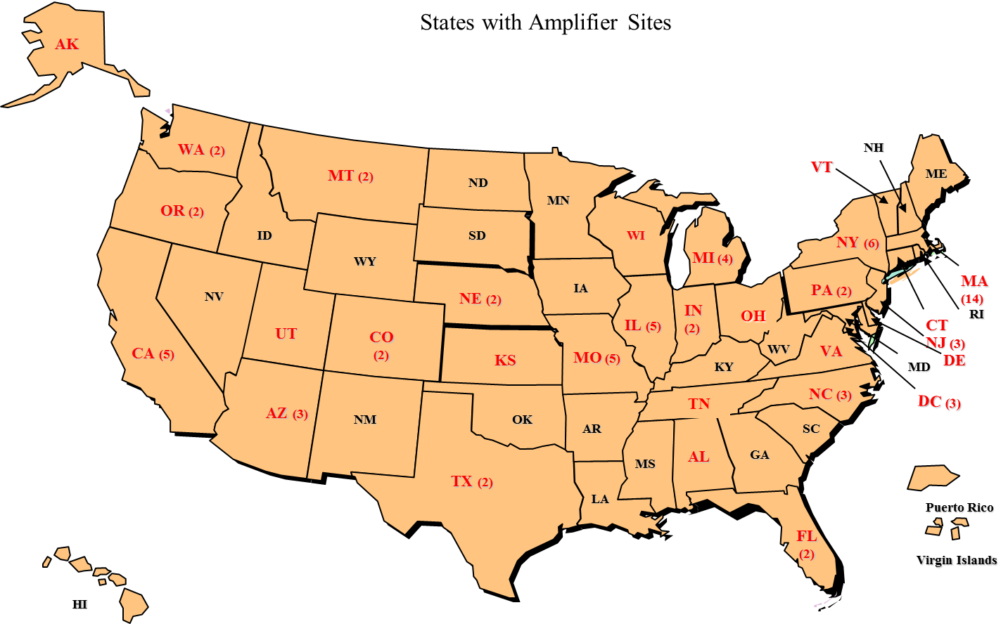

States with amplifier sites shown in red; multiple sites indicated in parentheses.

Feedback from participants indicates that while technical difficulties on the second day (lack of video capacity for some speakers) was a challenge, the material presented was very well received. Amplifier sites reported using the event to educate themselves and others, discuss plans and action strategies, build and strengthen networks, and make recommendations to policymakers. Some highlights from amplifier sites include:
- A Deputy Commander in the Army reported from Afghanistan that information from the event would be helpful in dealing with trauma in Kandahar.
- In Massachusetts, 23 topical sessions were held at 14 amplifier sites, with 300 people attending at least one session and many all four. Afterwards, participants summarized trends and themes from the event and made recommendations to the State Department of Mental Health leadership.
- A faith-based group reported using information from the event to build trauma-informed communities in one of the poorest areas of the country.
- The trauma-informed community initiative in rural Crawford County, Pennsylvania, reported that the event attracted new collaborators and partners to their effort.
- At the St. Louis Regional Health Commission, 150 people attended the keynote and “Communities” catalyst session as part of their effort to create a trauma-informed St. Louis.
- A site in Washington State called the meeting “the most amazing investment of time,” planned to share archived materials with senior administrators, and suggested that the Committee set up TED talks on this topic.
The event also led directly to new and expanded cooperative relationships at the Federal level, including a strengthened relationship with the White House Violence Against Women team; new Federal Partners Committee members from the U.S. Departments of Agriculture, Education, Health and Human Services, Homeland Security, and Justice; and new partnerships with the Bureau of Indian Affairs and Indian Health Services.
The interactive format, which allowed dialogue between the “Home Site” at DOL and participants through the WebEx platform “chat” function, contributed greatly to the success of the event. Many people commented that hearing questions from all over the country made them feel connected to a larger movement. The questions and speaker responses also provided important information about issues in the field. The vast majority of questions were directly related to implementation of trauma-informed approaches, including: strategies for building support and overcoming barriers, financing and regulations, and plans for addressing structural supports such as professional education and licensing. Several sites also made recommendations to the Federal Partners Committee, which included developing social marketing materials for communities interested in getting involved, and hosting in-depth, topic-specific events for sites that are further along in implementation.

Follow-Up and Next Steps
Following the event, the ACEs Connection site established a new online group called “Resilience USA” to host an ongoing discussion among event participants and others interested in building a “trauma-informed nation.” This group will serve as a platform to disseminate information and documents to inform national trauma-informed policy directions.

In March, 2016, the Committee held a planning retreat to review progress to date, learnings from the BTIN event, and remaining gaps and challenges. Priorities were established for the coming year, including two domains (the workforce and expanding the knowledge base) and several priority populations (youth/young adults, Native Americans, people diagnosed with serious mental illness, and the general public). The group also suggested that the Committee explore expanding its scope beyond women and girls.

Following the retreat, a strategic plan was developed for moving forward on a number of high-priority activities, including the formation of a centralized repository of information, a review and strategy for expansion of the evidence base for trauma-informed approaches, e-learning modules, the compilation and dissemination of evidence-based and emerging practices, and a review of the Committee’s scope. These activities are responsive to concerns raised by participants in the BTIN event and continue to build on the strong interagency collaboration of the Federal Partners Committee on Women and Trauma.

Acknowledgements

Special thanks to: the Planning Committee for endless hours of organizing; the U.S. Department of Labor for providing space, technical support, sign language interpreters, and CART transcription; the Health and Human Services Office of Women’s Health for providing the event website and managing event production; the Substance Abuse and Mental Health Services Administration for providing technical and strategic support for planning and writing the event report; the Federal agencies that supported speaker travel, materials, and other expenses; and especially the speakers, all of whom generously donated their time and expertise.

The following materials can be found at https://www.blsmeetings.net/traumainformednation/
- Planning committee
- Event agenda
- Power points
- Archived presentations
- Transcript of event

Archived presentations are also available at www.dol.gov/odep/topics/women.htm

