

**On April 3, 2023**, ETA transitioned to the PMS Financial Reporting System for grant recipient submission of the quarterly ETA-9130 financial reports. The following resources are available to assist with accessing PMS and submitting financial reports.

* **ETA-9130 Financial Report forms and instructions** may be found at: <http://www.dol.gov/agencies/eta/grants/management/reporting>
* **PMS Helpdesk at**: [https://pms.psc.gov/support/help-desk.html.](https://pms.psc.gov/support/help-desk.html)
* **ID.me Support Page:** <https://help.id.me/hc/en-us/p/contact_support>

To access PMS, ETA grant recipients **must** have an **ID.me** and **PMS User account**. New user access request for grant recipients will only be approved if you have an ID.me account. Grant recipients that do not have access to PMS should submit a new User Access Request to PMS. Grant recipients that currently have access to PMS and will be submitting/certifying ETA-9130 financial reports on behalf of their organization, should log in to PMS and update their permissions to request access to the ETA-9130 financial reporting forms.

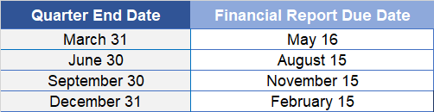

**Quarterly ETA-9130 Financial Reports are due by the following dates, unless otherwise specified in reporting instructions or by the Awarding agency.**

The POP Start Date in ETA's grants management system determines the due date of the initial ETA-9130 financial report. Examples of due dates for an initial ETA-9130 Financial Reports are:

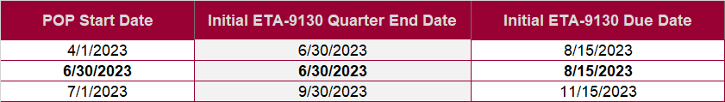



✓

For grants awarded **before November 12, 2020**, the Final financial 9130 report must be submitted no later than **90 calendar days** after the expiration of the grant period of performance.

For grants awarded **on and after November 12, 2020**, the Final **Financial** 9130 report must be submitted no later than **120 calendar days** after the expiration of the grant period of performance.

The closeout package will be emailed to the grant recipients within 7 days of the period of performance end date.

Examples of due dates for Final Financial Reports are:

|  |  |  |  |  |  |  |
| --- | --- | --- | --- | --- | --- | --- |
|  | **Grant POP** | **All Funds**  **Expended or POP Expired** | **Final Reporting** | | | **Final Report Due Date** |
|  | **Quarter End**  **Date** |  |
| **Awarded Before 11/12/2020 (90 Days)** | 07/1/17 –  09/30/20 | 09/30/2020 | 09/30/2020 | | | 12/30/2020 |
| **Awarded On or After 11/12/2020**  **(120 Days)** | 12/01/2020 –  09/30/2023 | 9/30/2023 | 9/30/2023 | | | 1/30/2024 |

Award recipients may request a POP amendment if all monies are expended prior to the end of the grant life cycle.